|  |  |  |  |  |  |  |  |  |  |  |  |  |  |  |  |  |  |  |  |  |  |  |  |  |  |  |  |  |  |  |  |  |  |  |  |  |  |  |  |  |  |  |  |  |  |  |  |  |  |  |  |  |  |  |  |  |  |  |  |  |  |  |  |
| --- | --- | --- | --- | --- | --- | --- | --- | --- | --- | --- | --- | --- | --- | --- | --- | --- | --- | --- | --- | --- | --- | --- | --- | --- | --- | --- | --- | --- | --- | --- | --- | --- | --- | --- | --- | --- | --- | --- | --- | --- | --- | --- | --- | --- | --- | --- | --- | --- | --- | --- | --- | --- | --- | --- | --- | --- | --- | --- | --- | --- | --- | --- | --- |
| |  |  |  |  |  |  |  |  |  |  |  | | --- | --- | --- | --- | --- | --- | --- | --- | --- | --- | --- | | **Software Design Specifications**  **Applying Federated Learning using Smart Contracts in Healthcare (DEDOC)**  **Version: 1.0**   |  |  | | --- | --- | | **Project Code** | F22-3006 | | **Supervisor** | DR FARRUKH SHAHID | | **Co Supervisor** | SHAHBAZ SIDDIQUI | | **Project Team** | Mansoor Butt (19K-1114)    Muhammad Khizer Jilani (19K-1057)  Sarmad Jamal (19K-1116) | | **Submission Date** | 25-NOV-2022 |     **Document History** |  |  |  |  |  | | --- | --- | --- | --- | | **Version** | **Name of Person** | **Date** | **Description of change** | | 0.1 | Whole team | 30-Oct | Document Created | | 0.2-0.5 | Whole team | 2-Nov | Added Introduction | | 0.6 | Khizer | 6-Nov | Added Overall System Description | | 0.7 | Sarmad | 18-Nov | Added External Interface Requirements | | 0.8 | Mansoor | 20-Nov | Added Functional Requirements | | 0.9 | Mansoor | 21-Nov | Added Non-Functional Requirements | | 1.0 | Whole Team | 24-Nov | Finalized |   **Distribution List**   |  |  | | --- | --- | | **Name** | **Role** | | DR FARRUKH SHAHID | Supervisor | | SHAHBAZ SIDDIQUI | Co Supervisor | |  |  |     **Document Sign-Off**     |  |  |  | | --- | --- | --- | | **Version** | **Sign-off Authority** | **Sign-off Date** | | 1.0 | Supervisor | 25-Nov | | 1.0 | Co-Supervisor | 25-Nov | | 1.0 | Jury | TBD | |

**Document Information**

|  |  |
| --- | --- |
| **Category** | **Information** |
| Customer | FAST-NU |
| Project | <Applying Federated Learning using smart contracts in health care> |
| Document | Software Design Specification |
| Document Version | 1.0 |
| Status | Draft |
| Author(s) | <Khizer Mansoor Sarmad> |
| Approver(s) | - |
| Issue Date | - |
| Document Location | - |
| Distribution | Advisor  Project Coordinator’s Office (through Advisor) |

**Definition of Terms, Acronyms and Abbreviations**

|  |  |
| --- | --- |
| **Term** | **Description** |
| ASP | Active Server Pages |
| DD | Design Specification |
|  |  |
|  |  |
|  |  |
|  |  |
|  |  |
|  |  |

# 

# 

# **Table of Contents**

Table of Contents

[**Table of Contents** 4](#_Toc120310151)

[**1** **Introduction** 5](#_Toc120310152)

[1.1 Purpose of Document 5](#_Toc120310153)

[1.2 Intended Audience 5](#_Toc120310154)

[1.3 Document Convention 5](#_Toc120310155)

[1.4 Project Overview 5](#_Toc120310156)

[1.5 Scope 5](#_Toc120310157)

[**2** **Design Considerations** 6](#_Toc120310158)

[2.1 Assumption and Dependencies 6](#_Toc120310159)

[2.2 Risk and Volatile Areas 6](#_Toc120310160)

[**3** **System Architecture** 7](#_Toc120310161)

[3.1 System Level Architecture 8](#_Toc120310162)

[3.2 Software Architecture 9](#_Toc120310163)

[**4** **Design Strategy** 10](#_Toc120310164)

[4.1 Future System Extension or Enhancement 10](#_Toc120310165)

[4.2 User Interface Paradigm 10](#_Toc120310166)

[4.3 Data Management 10](#_Toc120310167)

[**5** **Design Strategy** 11](#_Toc120310168)

[5.1 Database Design 11](#_Toc120310169)

[5.2 Application Design 11](#_Toc120310170)

[5.2.1 Sequence Diagram 11](#_Toc120310171)

[5.2.1.4<Sequence Diagram 4> 14](#_Toc120310172)

[15](#_Toc120310173)

[5.2.2 State Diagram 16](#_Toc120310174)

[18](#_Toc120310175)

[Appendices 18](#_Toc120310176)

[**6** **References** 20](#_Toc120310177)

[7 **Appendices** 20](#_Toc120310178)

# **Introduction**

## Purpose of Document

The purpose of this document is to describe briefly about our project which is a Medical Recommendation System and mobile app. This document will provide an overview of website and what problem it is solving, what are the requirements of this website. It also identifies the framework and a technology used for the development and tries to define the system architecture as well as design strategies use to build this website.

## Intended Audience

This document is intended for a varied set of audiences including Team Lead, Supervisors, Juries and Externals.

## Document Convention

The font size of this document is 12 pt. font style is Times New Roman.

## Project Overview

The objective of this project is to provide a Coordination Platform for Healthcare Sector and allow Model Sharing between hospitals through Federated Learning also develop a secure mechanism, upholding security and privacy of all participants by using Smart Contracts as a Protocol Enforcing Entity to maintain Integrity and Trust between all Hospitals and Achieve Interoperability between Blockchain and AI.

## Scope

Medical Recommendation system website is responsive. It is easy to use with a user-friendly interface for customers(hospitals), Receptionists will fill patient’s data and forward data to the relevant doctor, the doctor will examine the patient’s condition and will decide to admit it or not based on our system’s recommendation.

# **Design Considerations**

## Assumption and Dependencies

These assumptions are based on Hardware requirements for:

* 2.3 GHz of Processor
* 4 GB RAM
* 120 GB of HDD Space
* Keyboard and Mouse for Input
* Dedicated GPU of 2 GB Video Memory (optional)
* Broadcom 802.11b/g/n Network Adapter

***-General Assumption***

Hospital has its own Database & Management System

**-User Dependency**

Receptionist should know how to train model

**-Software Dependency**

IPFS depends on Smart Contracts

Hospital accepts/reject request of trainee model depends on behalf of smart contracts

## Risk and Volatile Areas

Overall training of Global Model can be increased if any hospital response of sending model is late. Due to the lack of excessive data, accuracy might be compromised. Currently our system is only recommending whether to admit or discharge a patient but in future the system might upgrade to recommending relevant prescription of the disease

# **System Architecture**

Hospital can request the model from the Global server then download the model. After downloading the model, they will be training it on their own data. After the training is completed, the model will be sent back to the global server this process will be repeated by all the hospitals on the network who are taking part in this training after all the models are received by the global server it will then aggregate all these models through ensemble learning and a new model with combined intelligence of all the aggregated model will be formed This new model will be delegated back to all the hospital.

## System Level Architecture

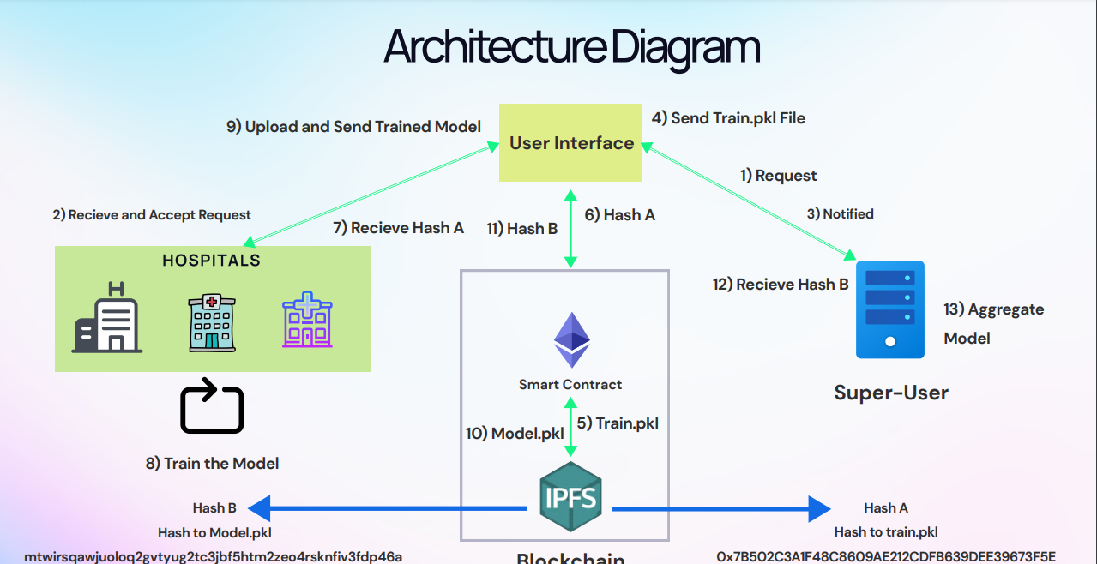

**High Level System Architecture**

## Software Architecture

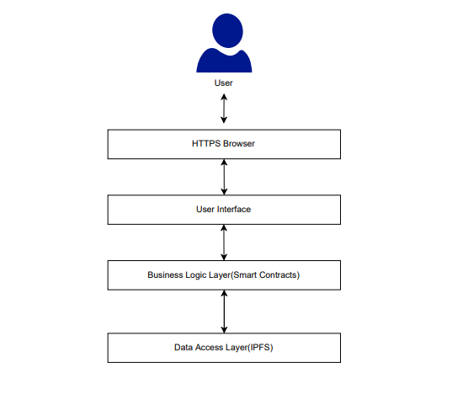

**Layered Software Architecture**

# **Design Strategy**

## Future System Extension or Enhancement

The system will be built using the latest edition of framework and incase a new update occurs in technology we must be ready. Stay updated by tracking orders with customized alerts and resolve issues proactively. Track real-time, Optimize routes and schedules and resource allocation in one centralized view.

## User Interface Paradigm

The user interface is very reliable and understandable to the user, the interface designed in such a way that mostly any expertise of people can easily learn and understand that what happens if I click this option, interface is very effective and efficient to increase the usability of users.

## Data Management

Main Data which are models will be stored on the IPFS and the relevant hashes of the model will be stored on smart contracts. Hospital will upload the model on web3 interface then store the model on the IPFS which will be use to apply federated leaning through aggregating of all these models.

Form typically collects the following data:

Patient Name

Fever

Blood Pressure

Heart Rate

Platelets

Blood Group

Weight

Age

ETC

# **Design Strategy**

## Database Design

**Not applicable (Database is being used to store data temporarily for authorization and registration purpose only, there are no other relations)**

## Application Design

## Sequence Diagram

#### 5.2.1.1<Sequence Diagram 1>

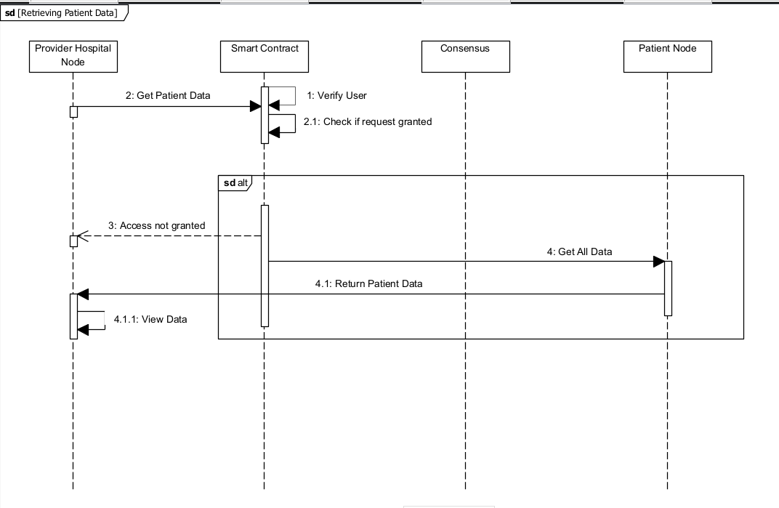

#### 5.2.1.2<Sequence Diagram 2>

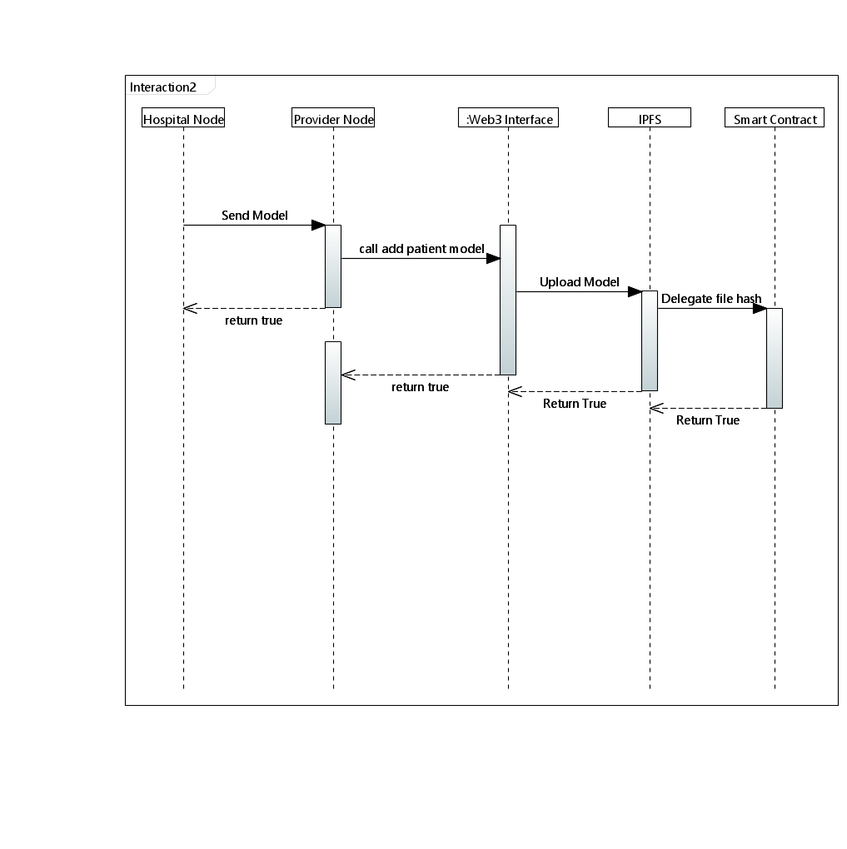

.

#### 5.2.1.3 <Sequence Diagram 3>

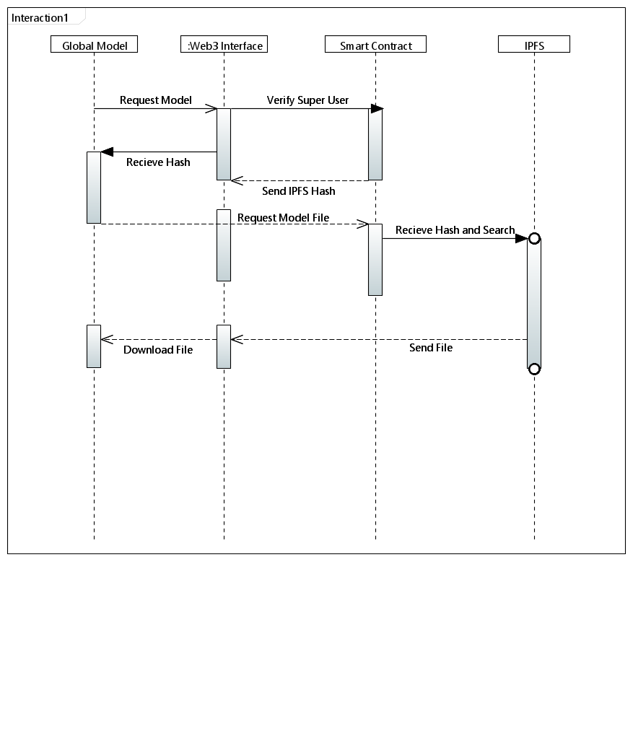

### 5.2.1.4<Sequence Diagram 4>

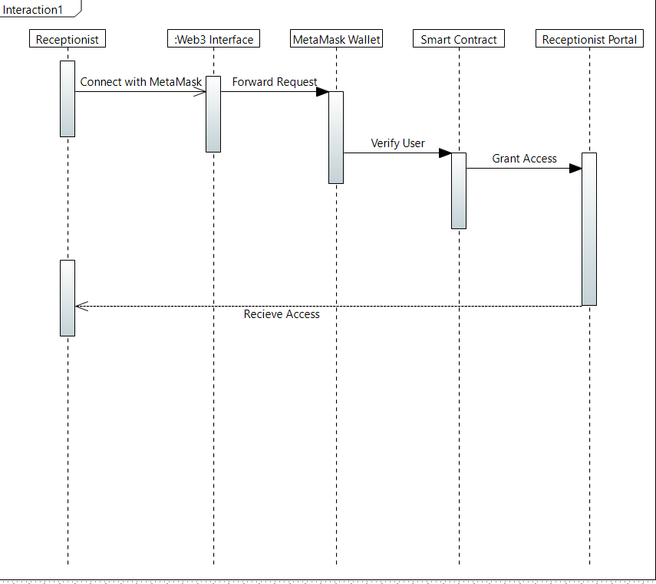

#### 5.2.1.5 <Sequence Diagram 5>

### Sequence_Diagram_1_Doctor_portal.drawio-1

## State Diagram

**5.2.2.1<State Diagram 1>**

**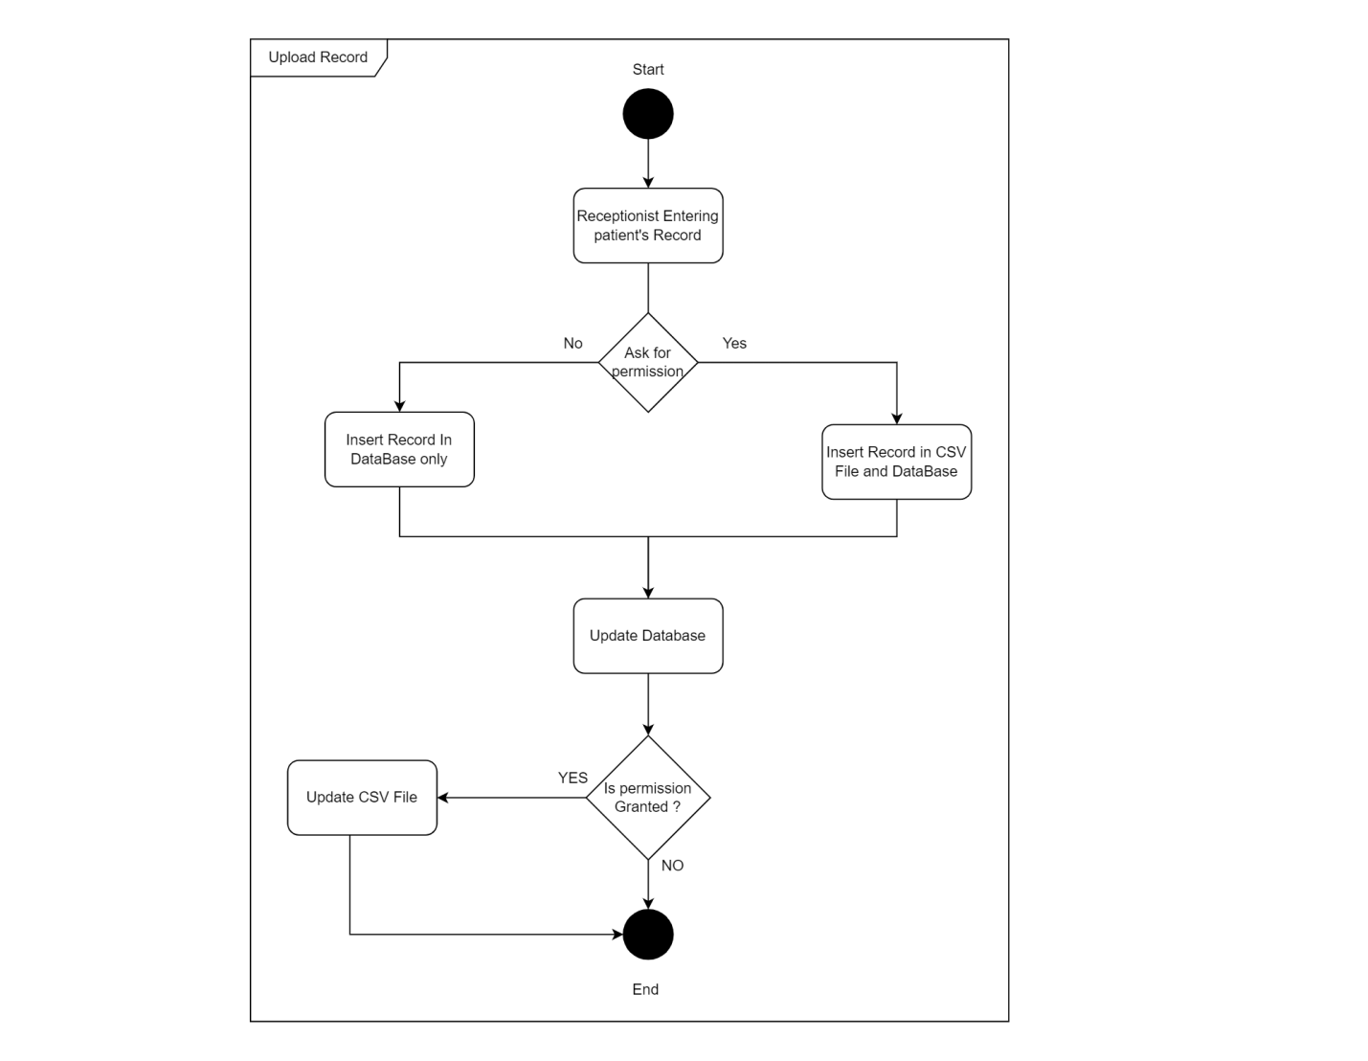**

**5.2.2.2<State Diagram 2>**

**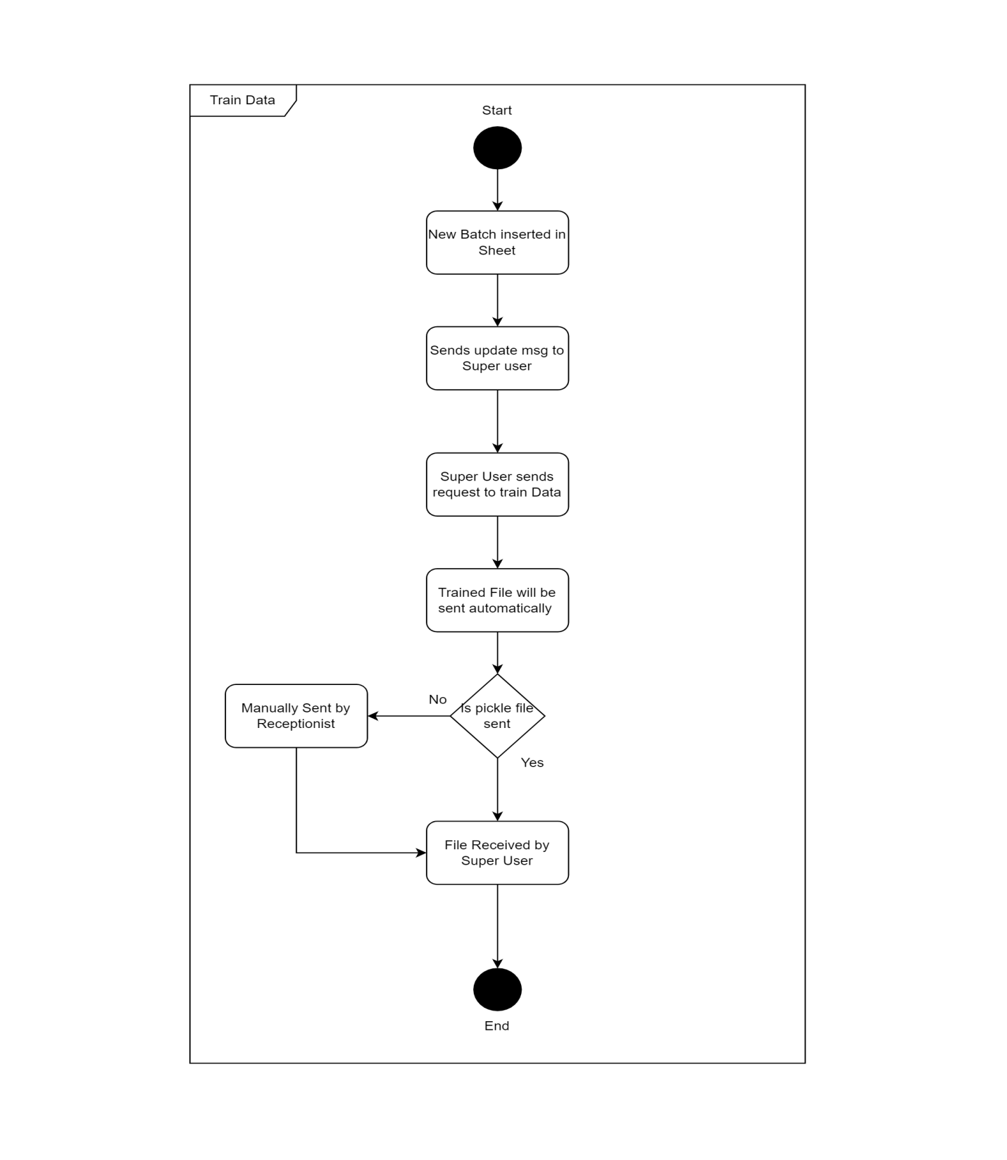**

References

*[This section should provide a complete list of all documents referenced at specific point in time. Each document should be identified by title, report number (if applicable), date, and publishing organization. Specify the sources from which the references can be obtained (This section is like the bibliography in a published book)].*

**5.2.2.3<State Diagram 3>**

# state 3

# Appendices

*[Include supporting detail that would be too distracting to include in the main body of the document.]*

**5.2.2.4<State Diagram 4>**

**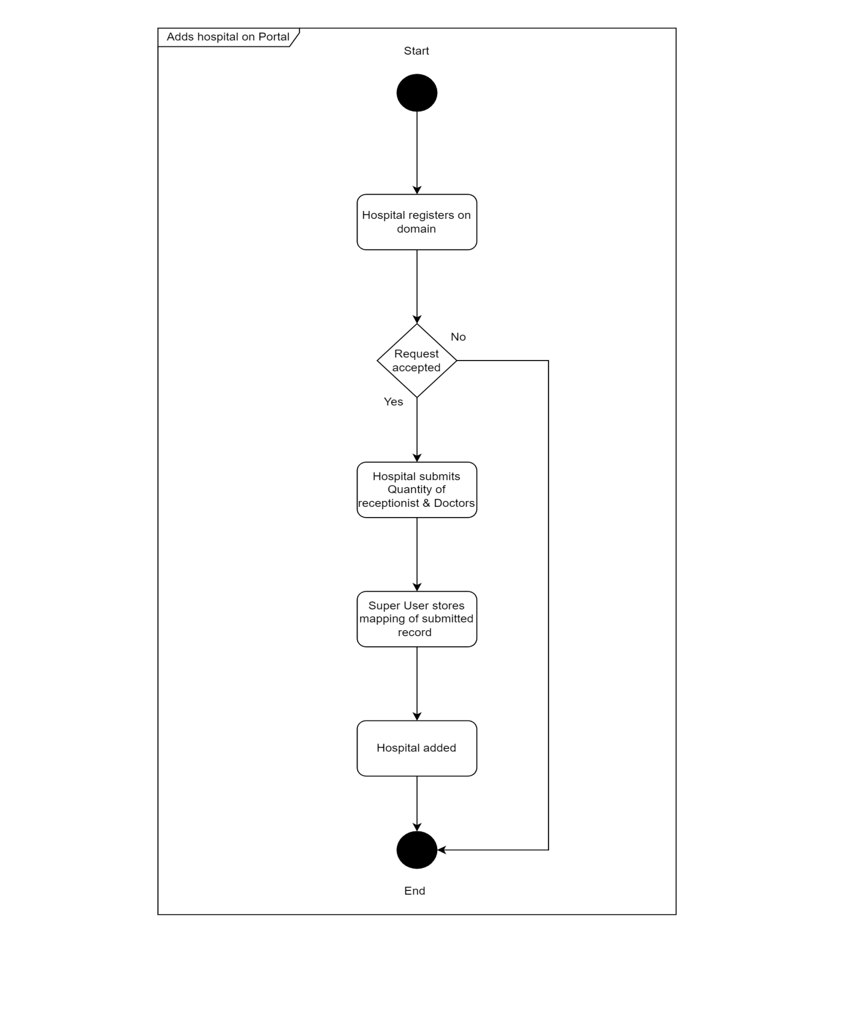**

# **References**

1. R. Roth, [M, Sheller](https://www.nature.com/articles/s41746-020-00323-1#auth-Micah-Sheller), “The future of digital health with federated

learning

”, September 2022, online: “<https://www.nature.com/articles/s41746-020-00323-1>”.

1. R. Stoffel et al,” Federated Learning for Healthcare: Systematic
2. Review and Architecture Proposal”, august 2022, online: ”<https://dl.acm.org/doi/10.1145/3501813>”
3. J.Xiu,C.Su,P.Walker, ”Federated Learning for Healthcare

Informatics”, November 2020, online: “[https://link.springer.com/article/10.1007/s41666-020-00082-4”](https://link.springer.com/article/10.1007/s41666-020-00082-4)

# **Appendices**